**Anaconda Installation Guide for Windows**

1. Go to <https://www.anaconda.com/products/distribution>. Click on the download button on the right-hand side.

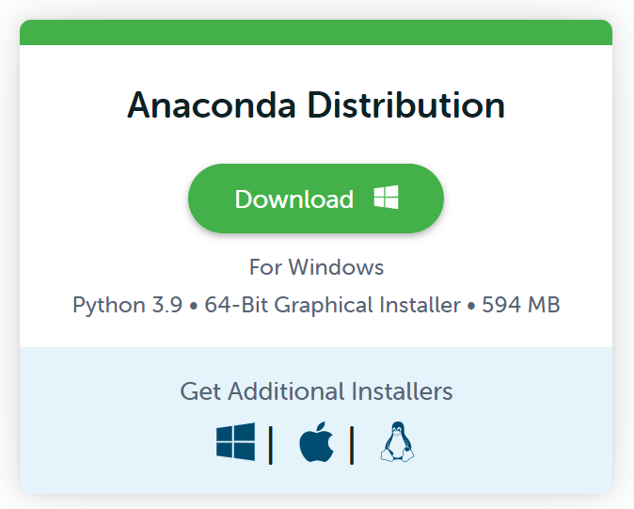

1. A file named **Anaconda3-2022.05-Windows-x86_64.exe** (or the latest version) will be downloaded. (Make sure you know where the downloaded file is stored on your laptop.)
2. Double click the downloaded file **Anaconda3-2022-05-Windows-x86_64.exe** to install the Anaconda package.

The Anaconda package contains Python 3.9 and Jupyter Notebook (that we will be using for editing and running Python files).

Use the default settings of the installer.

* 1. If you are prompted to install Microsoft Visual Studio Code, skip the step.
  2. You can uncheck the checkboxes “Learn more about Anaconda Cloud” and “Learn how to get started with Anaconda” unless you really want to learn more.

The installation may take a few minutes.

**To start editing and executing Python code using Jupyter Notebook:**

1. After installing Anaconda, search for “Jupyter Notebook” on the Windows search, and click on it.

You should see a black window opening (which we call a console window). There will be some text in the console window that informs you that the Jupyter Notebook application is being loaded.

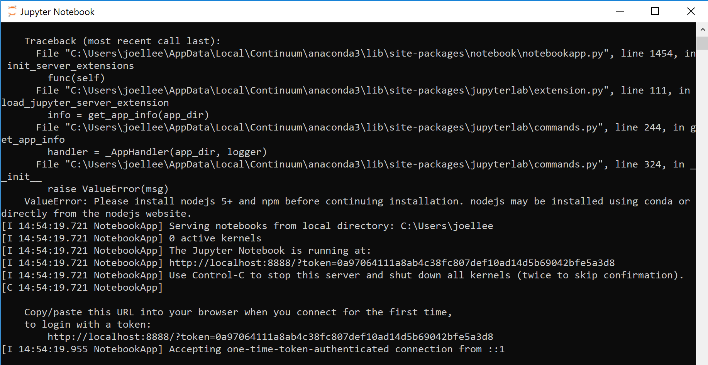

1. Then your laptop’s default browser will automatically open with an instance of **Jupyter Notebook** application as shown below (we recommend Google browser):

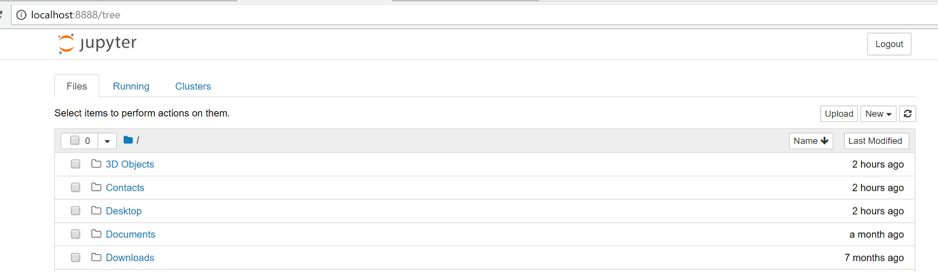

Note: If you use Chrome for the first time while opening Jupyter Notebook, you may encounter the following screen. Don’t worry!

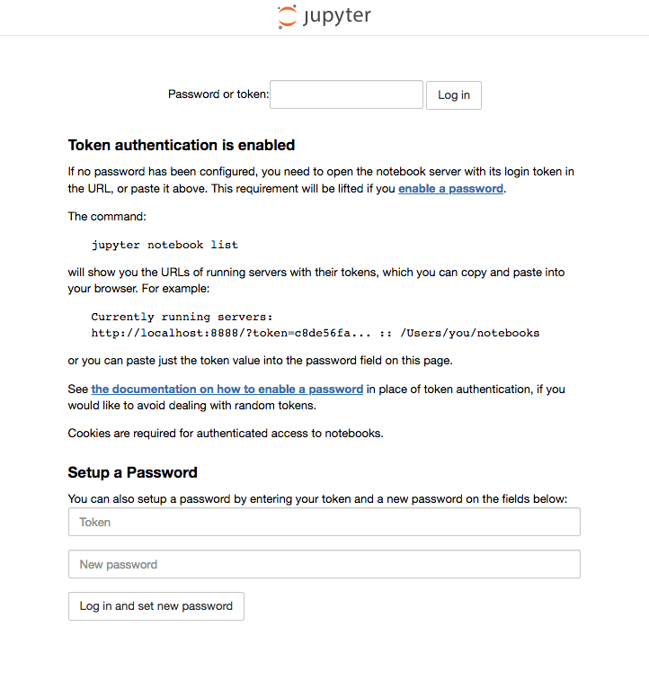

Just go to the console window below, copy the **token number** and paste it inside the above text box. Then press the **Log in** button. That is all!

You will have to do that the first time only.



The Jupyter Notebook environment can be used to edit and execute Python code.

More details will be given to you in class during the session.

**You are done with the installation!**

If you face issues in installing, please let us know before the lessons start or during the first lesson so that we can help solve the issue.

See you soon!